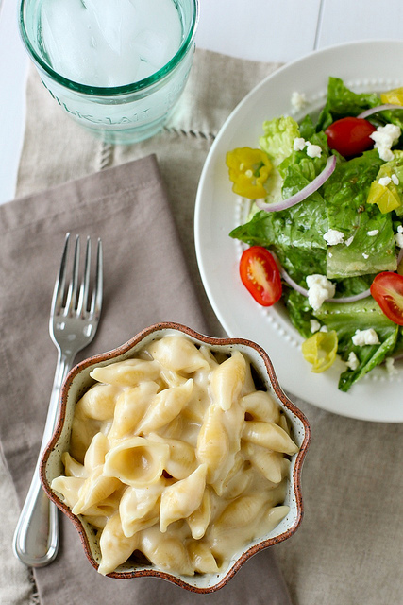

Panera Mac and Cheese

Yield: 4-5 servings

**Ingredients**

½ lb. pasta shapes, such as shells  
2 tbsp. unsalted butter  
2 TBSP all-purpose flour  
1 ¼ cups milk or half-and-half  
½ tsp. salt  
1tsp. Dijon mustard  
¼ tsp. hot sauce  
2 oz. white American cheese, finely chopped*  
4 oz. white cheddar cheese, shredded

\**White American cheese is available at the deli counter in most grocery stores.*

**Directions**

* Bring a large pot of water to boil.  Cook the pasta according to package directions until al dente.  Drain well.  Return to the stockpot off the heat.
* Meanwhile, in a medium saucepan, melt the butter over medium-high heat.  Stir in the flour and cook until light golden brown, whisking constantly, about 1½-2  minutes.  Slowly whisk in the milk until no lumps remain.  Stir in the salt, mustard, and hot sauce.  Lower the heat to medium and continue to cook the sauce, stirring frequently, until it bubbles and thickens, about 6-8 minutes.
* Remove the sauce from the heat.  Stir in the cheese a handful at a time, mixing until fully melted before adding more.  Once all the cheese has been added and the sauce is smooth, pour the sauce over the pasta in the stockpot.  Mix well until the pasta is fully coated in the sauce.  Serve immediately.